* 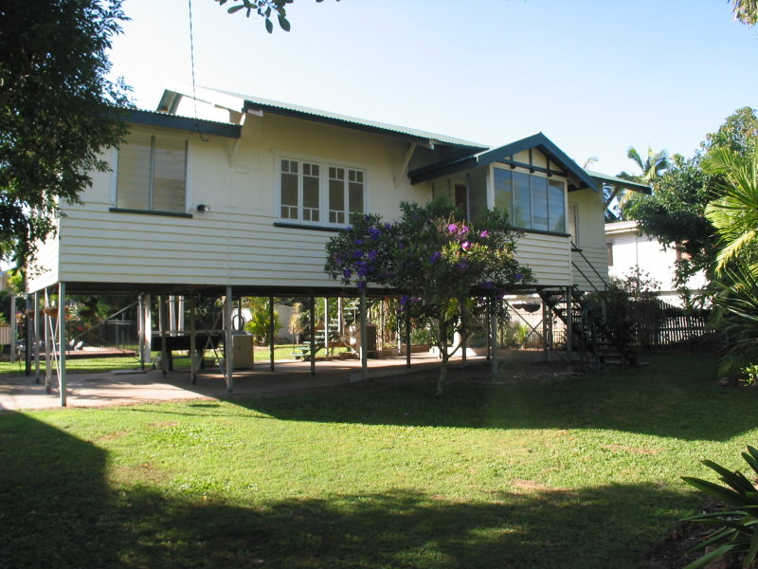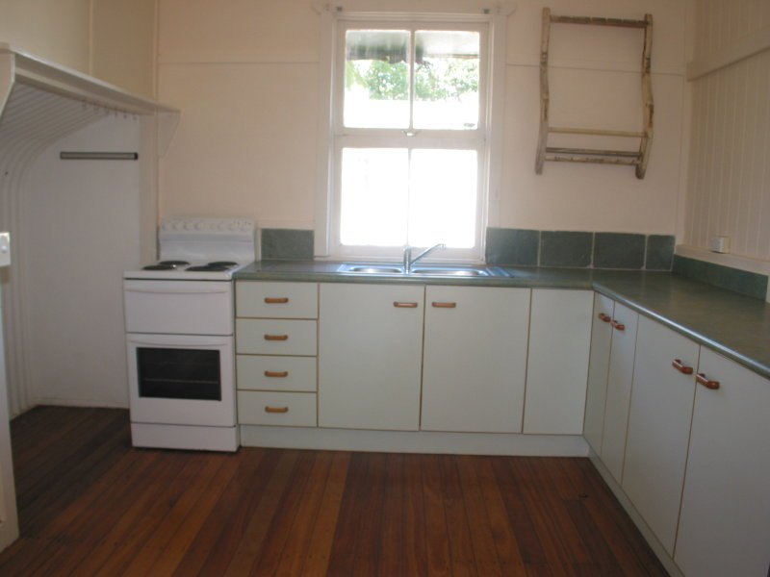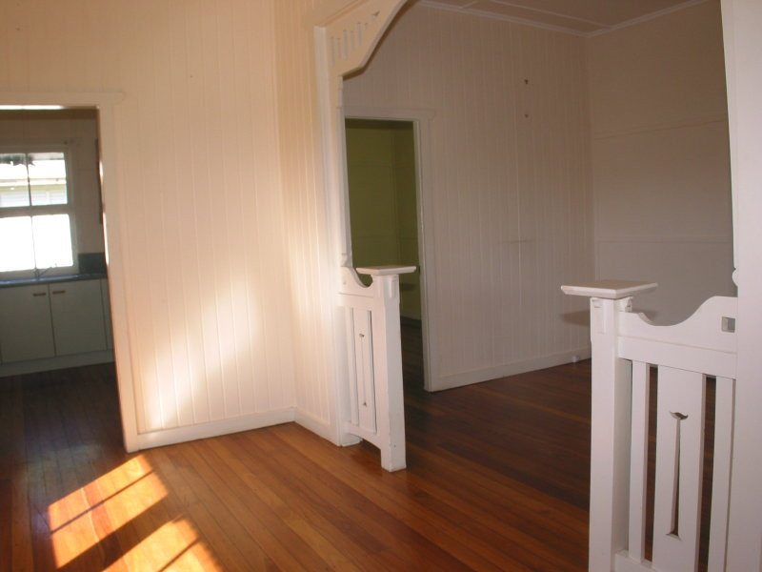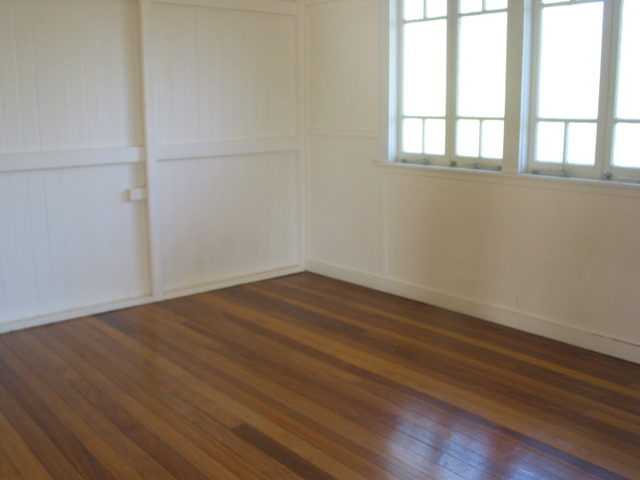$300 per week

\* 2 Bedrooms with Large Sleep Out  
\* 1 Bathroom  
\* Open Kitchen with LG Fridge Plumbed In  
\* Polished Floors throughout  
\* Air-Conditioning in all Living areas and Main Bedroom and Sleep Out   
\*Very Large Air-Conditioner would do the Second Bedroom as well  
\*Plunge Pool / Spa, Garden Shed with Lawnmower and Wheelbaroow included  
\* Fully Fenced Yard with Lovely Gardens